FORM G
G
SCHOOL:

STUDENT NUMBERS ATTENDING:
- Staff to student ratio is 1:20. (Dependant on participating student needs)
- Please send to RBSLEC, whenever numbers change.

BOYS: |  | GIRLS: |  | TOTAL:

***Please list any students attending that have not given media consent clearance to the school (captured on Form C)***
RBSLEC may use images of camp without student names.

Please clarify if visiting staff are the following: TA (Teacher Aide), ST (Student Teacher), PA (Parent assistant), PST (Pre Service Teacher) SEU (Special Ed Teacher). Please indicate if unavailable for standard duties.
STAFF NUMBERS ATTENDING: (Please print – full name and gender)

1 |  | 6
2 |  | 7
3 |  | 8
4 |  | 9
5 |  | 10

ARRIVALS & DEPARTURES: (please indicate)
The standard time for arrival at camp is 10am, we will arrive at ___________ .
The standard departure time from camp is 1pm, we will depart at _________ .
Yes we intend to leave early and will require a packed lunch. We understand that we are responsible for providing our own cool storage (ie. Esky) and managing handing out meals to students with special dietary requirements.

We will be arriving/departing camp by bus
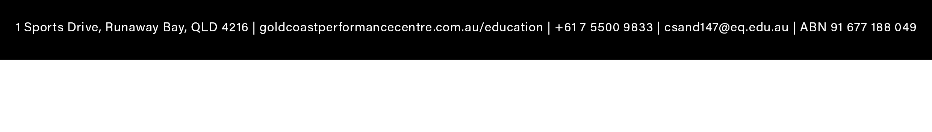
We will be arriving by private pick-up/drop/off

***It is the visiting schools’ responsibility to collate Form C’s (Medical & Consent) and ensure all information (including signed consent) is captured on each individual form with relevant details communicated on this Form G***

